Task 2.2

1. Create profiles on 3 different job boards and upload your resume
2. **Indeed**

1. **ZipRecruiter**

1. **Monster**

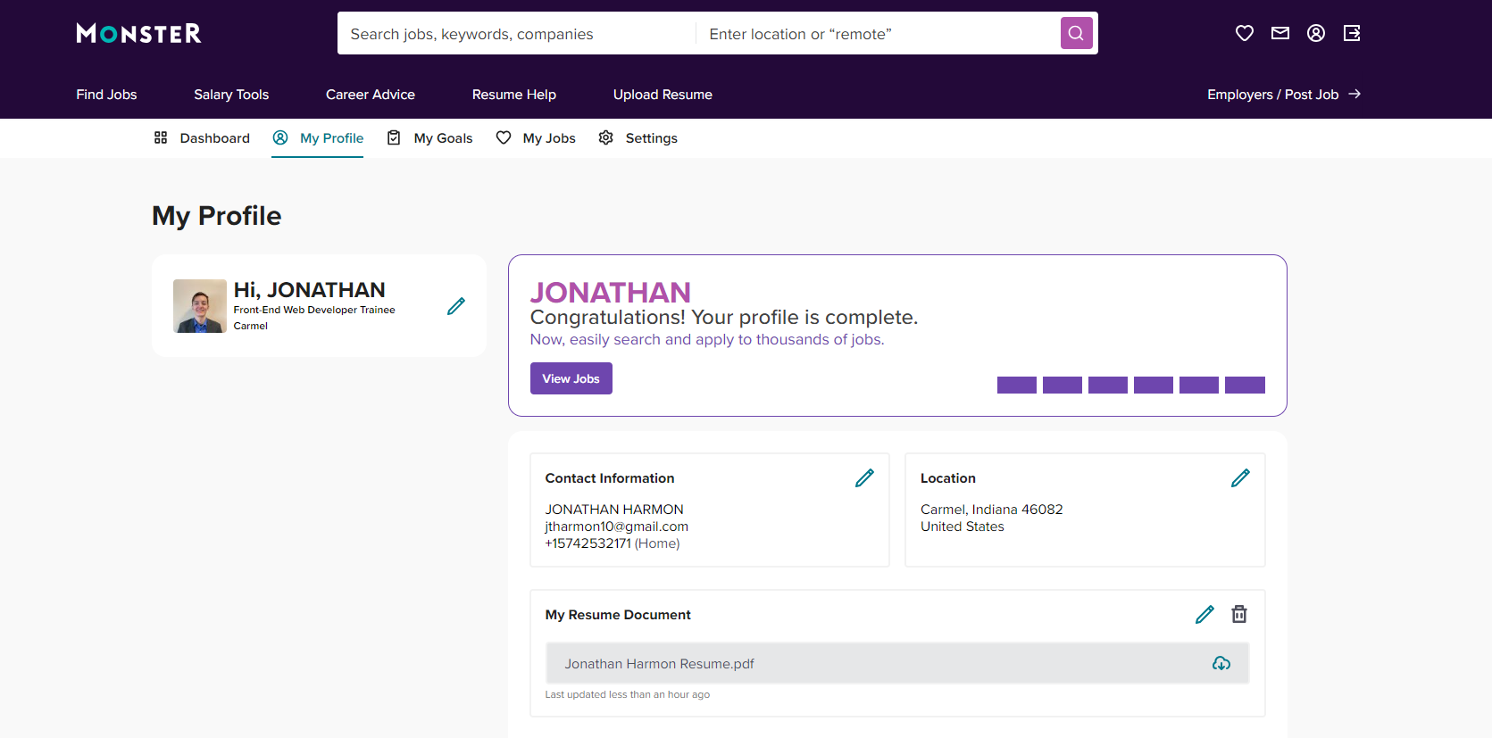

1. **10 open positions that I could apply for**
2. Braintrust
   1. Front End Developer
   2. Remote
   3. LinkedIn
   4. <https://www.linkedin.com/jobs/view/3660244258/?alternateChannel=search&refId=0T3fQw4v4GHwi99oc25EIg%3D%3D&trackingId=0T3fQw4v4GHwi99oc25EIg%3D%3D>
3. Zinc Partners LLC
   1. Software Engineer
   2. Hybrid
   3. LinkedIn
   4. <https://www.linkedin.com/jobs/view/3663408145/?refId=085982fb-8353-4efb-b4d7-f14e50ebddac&trackingId=zmtyIBZ3TMWJETlPQuGjoQ%3D%3D>
4. Tree Top Staffing LLC
   1. Web Developer
   2. Remote
   3. LinkedIn
   4. <https://www.linkedin.com/jobs/view/3660035911/?refId=d1bc621f-3832-4d95-a7a9-febfc27dcdb3&trackingId=02214zFOQg63mPOdENb97Q%3D%3D&trk=flagship3_job_home_appliedjobs&lipi=urn%3Ali%3Apage%3Ad_flagship3_myitems_savedjobs%3Bu%2BaogMDjTQ%2Bm7tAGr10tiQ%3D%3D>
5. Generac Power Systems
   1. Full Stack Developer
   2. Remote
   3. Referral/LinkedIn
   4. <https://generacta.avature.net/careers/JobDetail/Waukesha-Wisconsin-United-States-Full-Stack-Developer-net/10071>